ФИО | Тодорова Полина Сергеевна
Класс/возраст | 10В, 16 лет
Наименование ОУ | Муниципальное бюджетное образовательное учреждение «Сургутская технологическая школа»
Иностранный язык | Английский язык
ФИО и должность наставника | Касаева Полина Викторовна, учитель английского языка
Контактные данные наставника | poooolina@mail.ru, 89048787758

Every culture in our world has an unimaginable value and significance for us. Asking people about their culture, they tend to describe it with enthusiasm and delight. That is how I feel about the culture of my region, where the most significant position is occupied by Khanty and Mansi, wonderful and positive native people of the north.
Without a doubt, such extraordinary people should be heard! I value the cultural heritage of my region and I want as many people as possible to know about it! The Khanty and Mansi are small indigenous peoples of Siberia, namely the Khanty-Mansi Autonomous Okrug. They lead a semi-sedentary lifestyle, and those of them who are engaged in reindeer husbandry lead a nomadic lifestyle. Their main occupation is hunting and fishing.
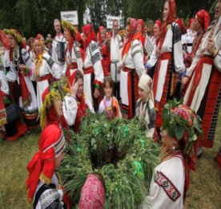
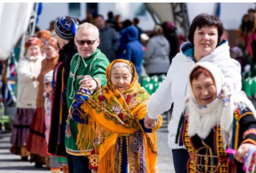
The Khanty and Mansi, like every nation, have their own amazing customs and traditions. For example, in this wonderful picture on the left the native people are dressed in their folk costumes, demonstrating respect for their history and traditions. In the second photo on the right we see the process of celebrating a holiday and it can be noticed that absolutely everyone is involved in it: children, teenagers, adults and elderly people. Steadfastness is another significant trait of the people. In any weather, they are ready to honor and respect their heritage.

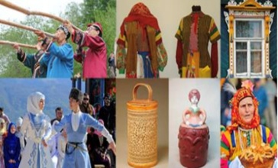
It should be noted that the Khanty and Mansi are very talented people. They make all products by hand, and also put all their love into their creations. From an early age, the Khanty and Mansi teach their young generation to craft and develop inventive skills.

In conclusion, I can safely say that I am proud of my cultural heritage! I hope that the unique Khanty and Mansi people and their culture will become much more popular and will interest other people of our country more and more.

